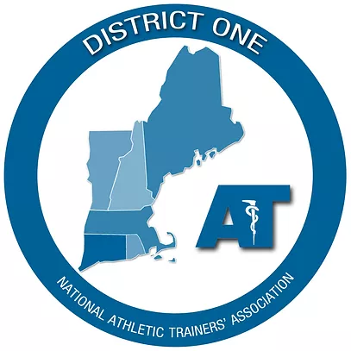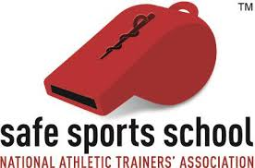

District One Safe Sports School Award Grant Program
Procedures and Application
Eligibility & Requirements:

- Members of NATA District One may apply for a District One Grant on behalf of schools that are first-time applicants for the Safe Sports School Award (SSSA). The grant covers the full cost of the application for the award ($150).

2. The athletic trainer applying for the award must: (1) be a NATA member in good standing; (2) be a member of NATA District One; (3) have a National Provider Identifier (NPI) number; (4) be in good standing with the Board of Certification, Inc. (BOC); (5) have a current license to practice as an athletic trainer in the state in which the school is located.

3. Enrollment and completion of the current year survey in the NATA ATLAS Program is required.

4. The District One SSSA Grant and NATA SSSA have separate applications and processes. The member must apply for the District One Safe Sports School Award Grant prior to the final submission of the application to the NATA for the SSSA.

If you have any questions about the application process for the District One SSSA Grant or the Safe Sports School Award itself, please contact District One SSATC representative Amy Wiggins at: amyvwiggins@gmail.com for assistance.

Instructions
Part I:
- Complete the District One SSSA Grant Application.
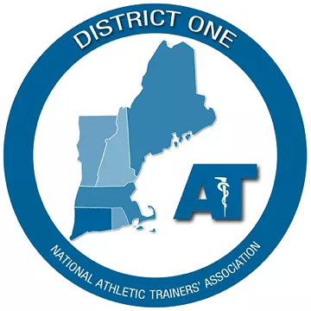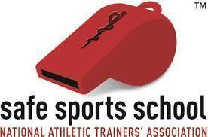

District One Safe Sports School Grant Application

Member (athletic trainer) submitting application: __________________________________________

Name of School: _________________________________ Date of grant application: ______________

School Address: ____________________________________________________________________

City: ____________________ State: _____ Zip: _______

Member Information:

Phone (including area code): _______________________________________

E-mail address: ____________________________________________

NATA Member # _________________________ NPI # _____________________________

BOC # ______________________________________ State License # _________________________

Is the school currently enrolled in NATA ATLAS? Yes □ No □

Is this a first-time application for the Safe Sports School Award? Yes □ No □

Please indicate whether this application meets the criteria for a 1st or 2nd team award. 1st □ 2nd □

I hereby represent and warrant that, to my reasonable knowledge, the information set forth above is accurate, correct, and complete.

Signature – Your Typed Name Above Will Be Considered Your Signature

Supplemental Materials to be Submitted with the District One SSSA Grant application:
- Copy of Safe Sports School Award application
- Copy of confirmation e-mail of School Admin approval of application

Part II:
- Complete the NATA Safe Sport School Award (SSSA) application (Step 1 of 4).
- The SSSA application is an online application HERE
NOTE: 1) If you get a message that you are not authorized to access the page, make sure are you logged-in to your NATA member account.
- Click the “Notify School Admin” button to send them an email notification with links for their response (Step 2 of 4).
- You’ll receive an e-mail informing you that your School Admin has approved the SSSA application and instructing you to complete the application process (Step 3 of 4). STOP HERE and DO NOT complete Step 4 of the application yet.
- Take a screenshot of the e-mail confirmation you receive stating that your School Admin has approved the SSSA application. You may also save the e-mail as a PDF.
- Save a copy of your SSSA application as a PDF (via choosing Save as PDF from the “printer-friendly version” dialog box at the top of the page) or as a Word document (via copy & pasting the entire application into a Word document).

Part III:
Submit the following documents to the D1 Secondary School Committee Representative
Amy Wiggins at: amyvwiggins@gmail.com

- District One SSSA Grant Application.
- Copy of your SSSA application (PDF or Word document).
- Screenshot or PDF of the e-mail confirmation that your School Admin has approved the SSSA application.

Part IV:
- You will be notified by the District One Treasurer when your District One Grant application is approved.
- Once you have been notified that you have received the grant, you may complete the SSSA application process online (Step 4 of 4). Make sure to complete the boxes indicating you will receive funds from District One in the amount of $150.
- The NATA will contact you regarding the status of your application for the Safe Sports School Award.
- District One Grant funds will be disbursed directly to the NATA.
Application updated: 10/1/2022

